Fltterning json data 5

Dataset 5= emp_details_4

[

{

"id":"101",

"name":"srinivas",

"gender":"male",

"address":{

            "city":"Hyderabad",

            "country":"india"

          }

},

{

"id":"102",

"name":"phani",

"gender":"male",

"address":{

            "city":"Hyderabad",

            "country":"india"

          }

}

]

1. Go to dataflow add source like added previously for multiline json

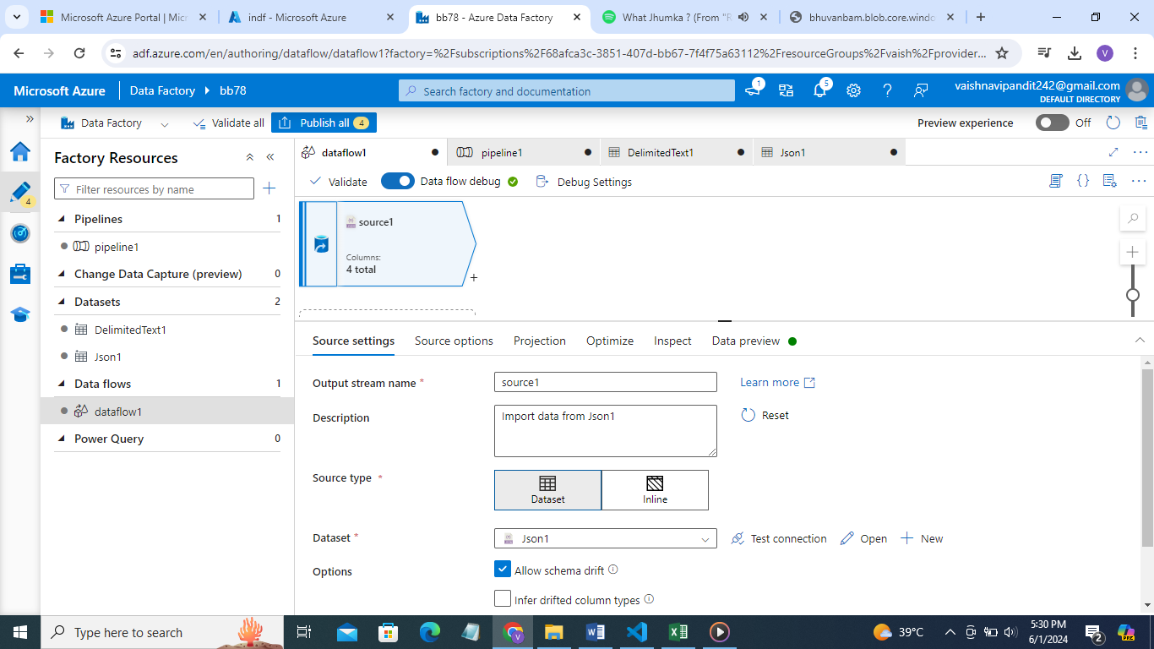

1. Now go to projection you will see how columns are divided address column will contain 2 more columns in it for city and country

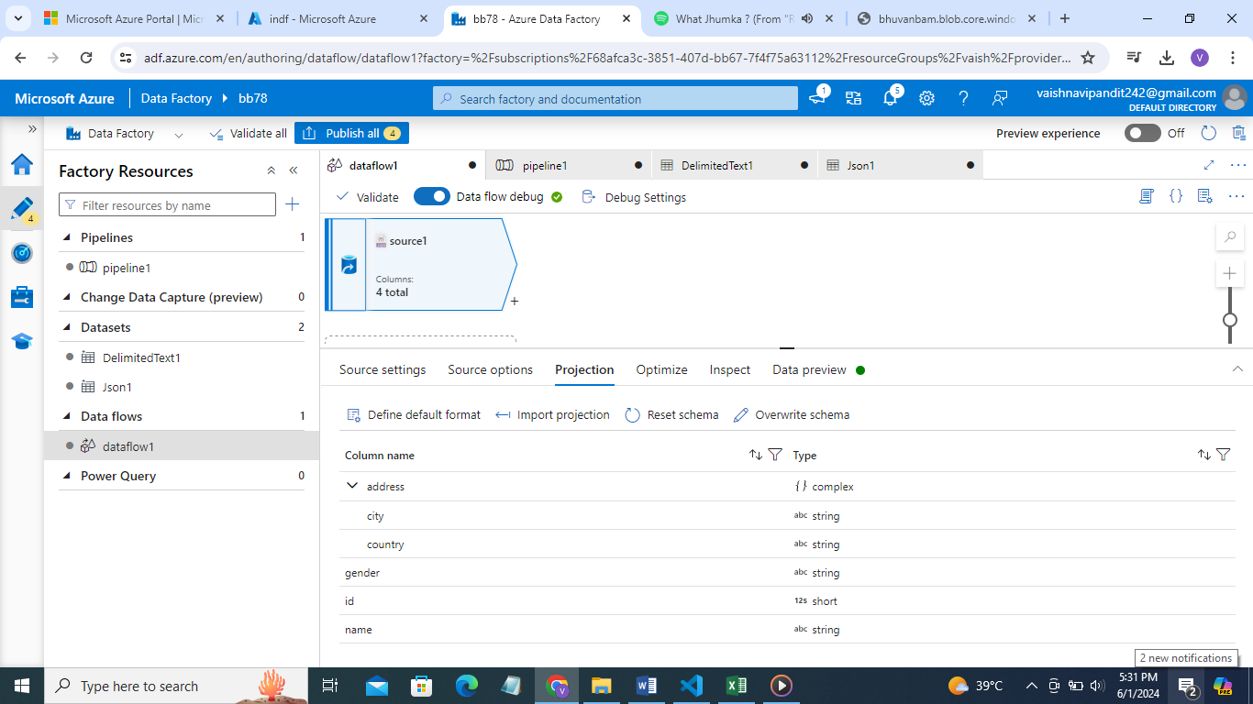

1. Now go see preview

Still data is not flatterned as we don’t want colum to divide into multiple columns we want single column not in herarchical format

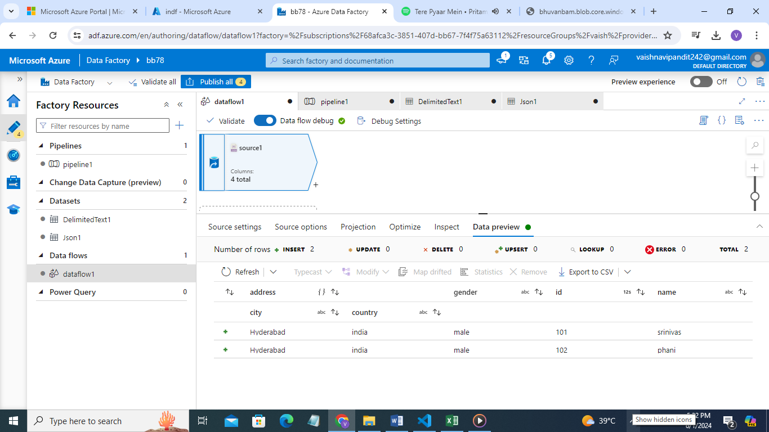

1. That’s why create more two columns for city and country and add values there and delete the address column

Go to +->select derived column

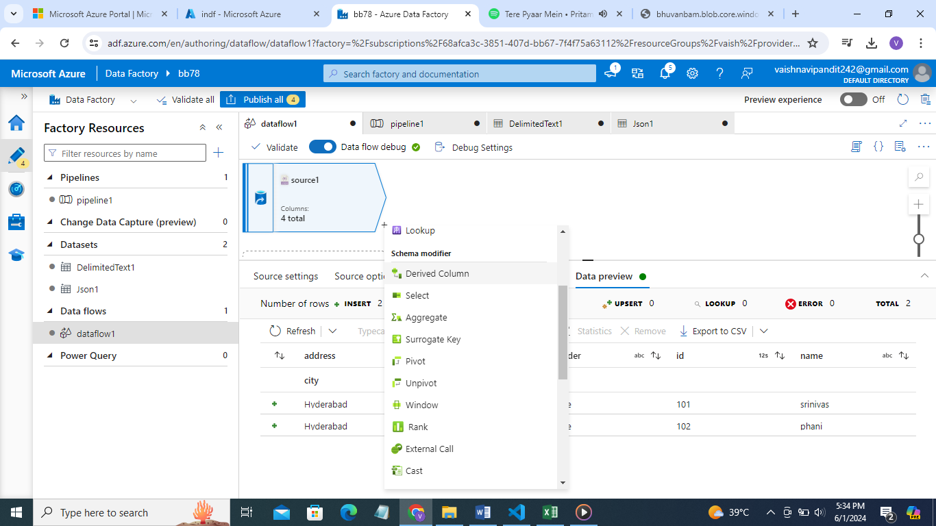

1. Add column city and country in expression write address.city, address.country respectively

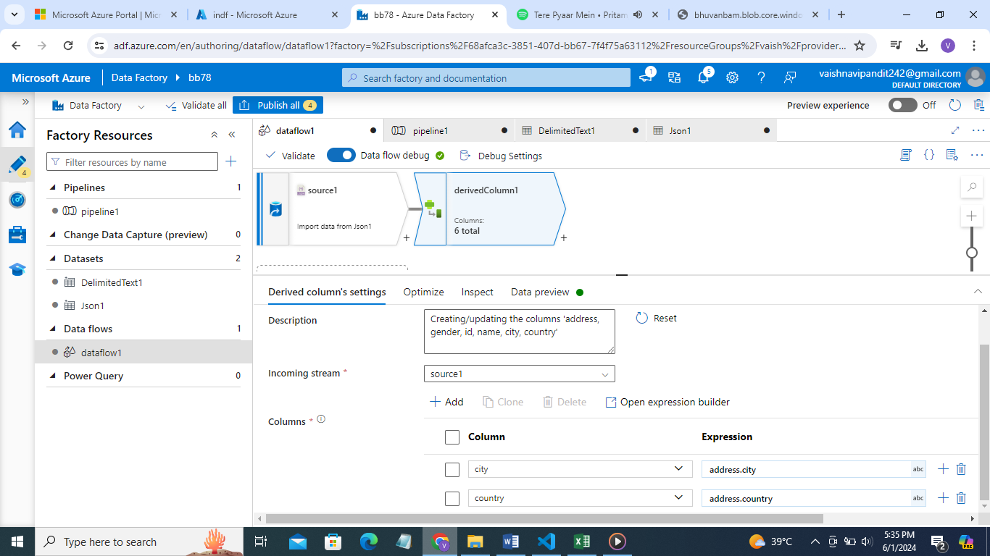

1. Now go to+->select ‘select’ and delete column country all the other columns will be selected

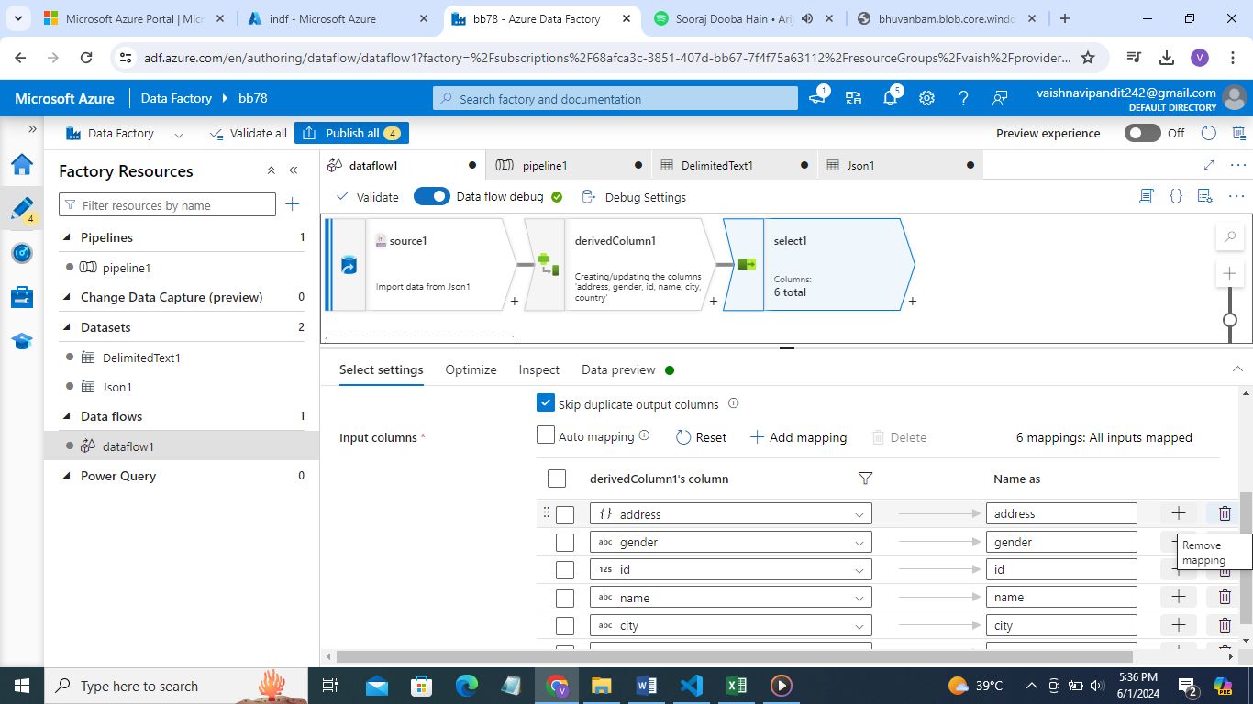

1. Delete

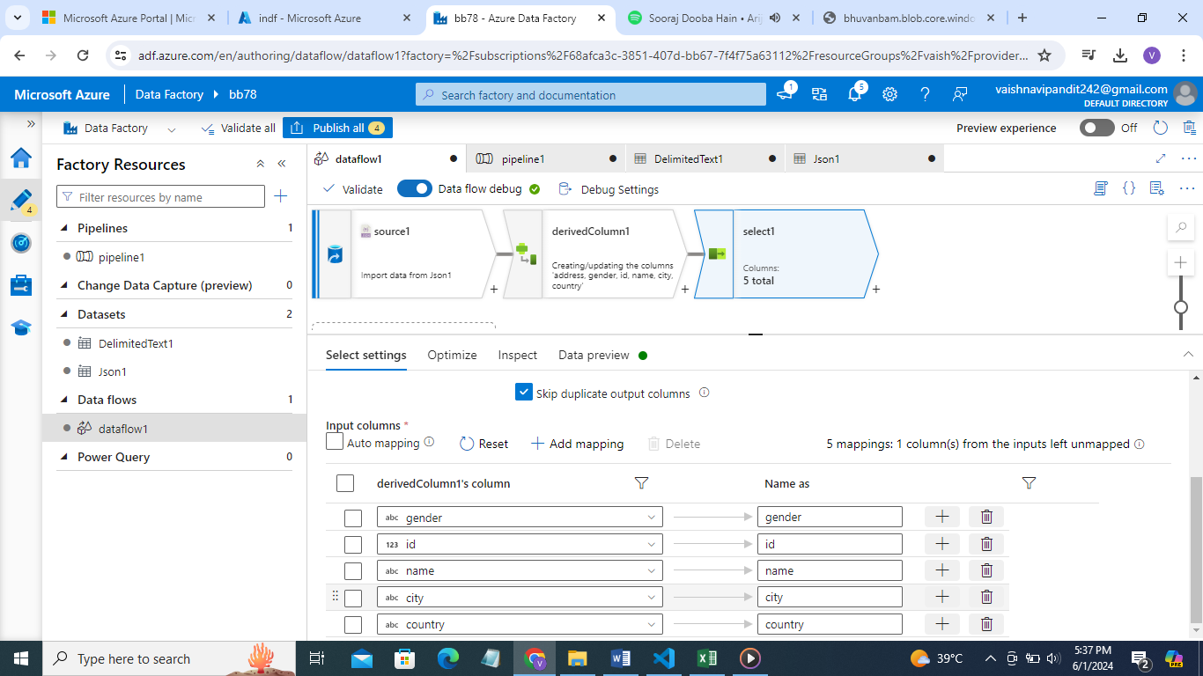

1. See preview

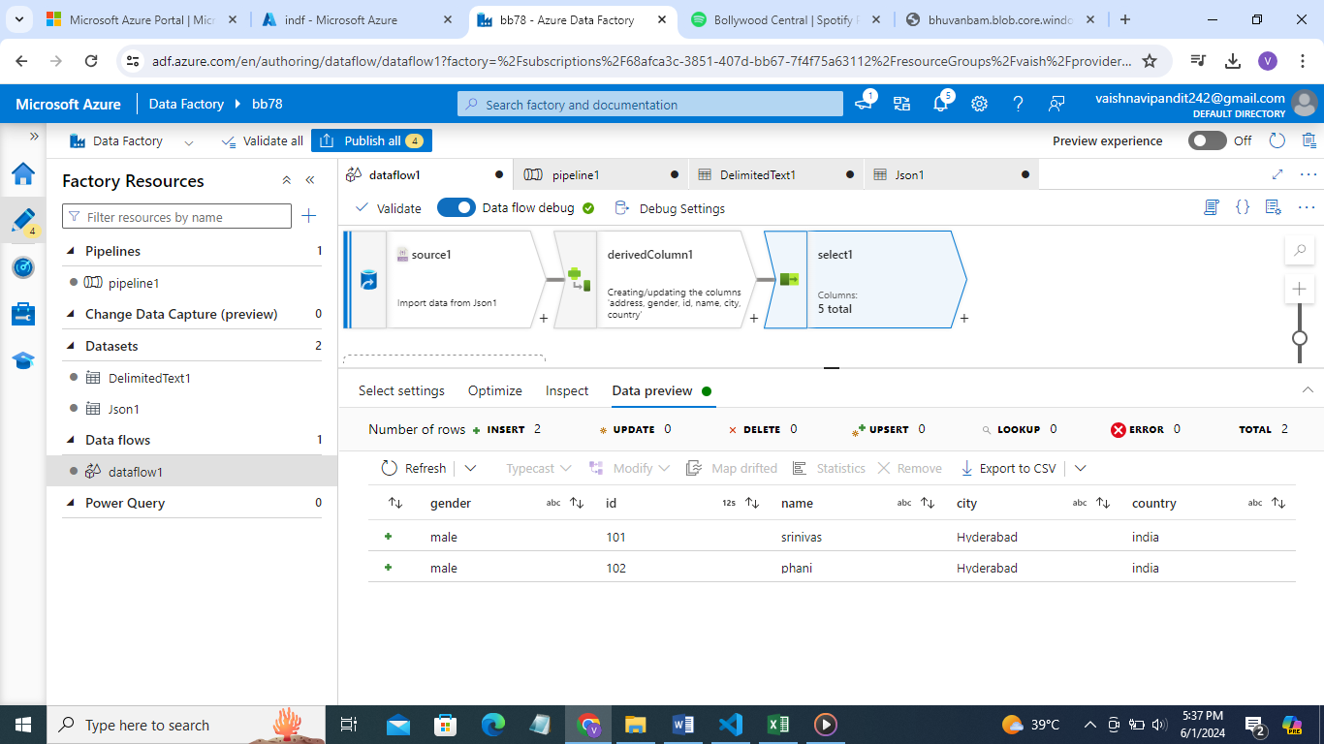

1. Now add sink to a database where you want to store this as table and select add table and add pipeline debug